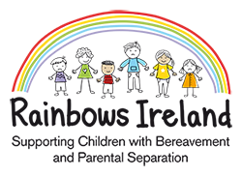****

**St. Kevin’s FRC, Kilnamanagh & Killinarden FRC, Tallaght**

**Rainbows Bereavement & Parental Separation**

**Expression of Interest Form**

|  |  |
| --- | --- |
| Child / young person’s name: |  |
| Child’s date of birth: |  |
| Class level from September 2025 |  |
| Loss type: (please highlight /circle as appropriate) | Bereavement Parental Separation |
| **Rainbows Ireland is inclusive of both parents. please include the following information** | |
| Parent/Guardian  Name: |  |
| Parent/Guardian  Mobile number: |  |
| Parent/Guardian  Email address: |  |
| Parent/Guardian  Name: |  |
| Parent/Guardian  Mobile number: |  |
| Parent/Guardian  Email address: |  |
| Date of returning completed form: |  |

St Kevins Family Resource Centre work closely with Killinarden Family Resource Centre in our waiting lists. We do this so child have the opportunity to attend a Rainbows group quicker. Do we have your permission to share your child’s information with Killinarden FRC for the purpose of Rainbows programme only. Please circle and sign

Yes No

______________________ _______________________

Thank you for your enquiry.

Please complete this form and email to the Rainbows Coordinator at:

[coordinator@stkevinsfrc.ie](mailto:coordinator@stkevinsfrc.ie)