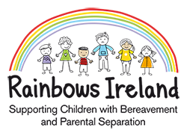

Expression of Interest Form

Rainbows centre name: St. Kevin’s Family Resource Centre

Child’s name: ________________________________________________________________

Age & date of birth: ________________________________________________________________

Class level from Sept 2021: ________________________________________________________________

Loss type: (please circle as appropriate) Bereavement Parental Separation

Parent/Guardian name: ________________________________________________________________

Parent/Guardian mobile number: ___________________________________________________________

Parent/Guardian email address: ___________________________________________________________

Have you attended a Rainbows programme before: Yes No

If yes, when and where: ________________________________________________________________

The Rainbows Coordinator can be contacted on 01-4627149.

For official use only:

Date received in office
Date of follow up call
Attending Parent Information meeting (circle as appropriate) | Yes | No
Other notes/comments

